

D2.1
Set-up of first
topical groups

EXECUTIVE SUMMARY
Deliverable No. | 2.1
Deliverable Name | Set-up of first topical groups
Work Package | Community of Practice
Contractual Date | 31 July 2025
Deliverable Date | 25 July 2025
Main author | Pauline Bordiec (FOREU4ALL Central Office, WP2 Project Officer)
Contributors | FOREU4ALL Project Management Team (PMT): Ludovic Thilly (EC2U, WP2 Leader and WP1 co-Leader), Alison Garnier Rivers (EPICUR, WP2 co-Leader), , Olga Wessels (ECIU, WP1 Leader), Kevin Guillaume (Circle U., WP3 Leader), Sophia Karner (Una Europa, WP3 co-Leader), Meritxell Chaves (CHARM-EU, WP4 Leader), Naveed Syed (ENHANCE, WP4 co-Leader), Giulia Falchi and Paula Talero (FOREU4ALL Central Office)  FOREU4ALL WP2 Board members: Mattia Belotti (EUTOPIA), Mona Roman (U!REKA), Dorothy Kelly (Arqus) and Michal Karpisek (E²UDRES³)  FOREU4ALL Topical Group Chairing Teams and Group members (> 2000 participants)
Dissemination Level | Public
Version/ Update | Version 4.0
Summary | This deliverable presents the processes established by WP2 for the selection, management, monitoring and evaluation of the topical groups. It also includes each topical group’s Terms of Reference and details on the communication and dissemination strategy defined to promote their launch at the internal and external levels.

Document history
Date | Revision n° | Prepared by | Description
16/06/2025 | V1.0 | Pauline Bordiec | Table of content and first version of the content and of the annexes
23/06/2025 | V1.1 | Ludovic Thilly | First overall review
26/06/2025 | V2.0 | Pauline Bordiec | Integration of suggested modifications and of Terms of Reference provided by Topical Group Chairing Teams
07/07/2025 | V2.1 | Pauline Bordiec | Integration of remaining Terms of Reference
10/07/2025 | V2.2 | WP2 Board members | Second overall review
11/07/2025 | V3.0 | Pauline Bordiec | Integration of suggested modifications
17/07/2025 | V3.1 | PMT members | Third overall review
21/07/2025 | V4.0 | Pauline Bordiec | Integration of suggested modifications

TABLE OF CONTENT
I. INTRODUCTION 5
II. SELECTION PROCESS 6
III. MANAGEMENT, MONITORING AND EVALUATION PROCESSES 11
1. Topical group membership 11
2. Topical group management 11
3. Topical group monitoring 12
4. Evaluation of topical groups 13
IV. TOPICAL GROUPS COMMUNICATION STRATEGY 15
1. Internal strategy 15
2. External strategy 17
V. TEMPLATES 21
1. Agenda template 21
2. Minutes template 22
VI. CONCLUSION 23

INTRODUCTION
This deliverable focuses on the creation and launch of the Community of Practice (CoP) topical groups.

Since 2020 and the creation of the informal FOREU network, several informal topical groups (9 groups in FOREU1 and 16 groups in FOREU2) were already setup for alliances to exchange best practices, challenges and work on common tools, papers and/or resources.

The FOREU4ALL project thus builds on these existing informal networks to setup the CoP topical groups. To that end, clear processes and procedures were defined to select, manage, monitor and evaluate the topical groups both at the topical group and CoP level.

A formal call for topical groups was first launched in December 2024 to alliances. It was possible to either propose the continuation of informal groups or the creation of new topical groups. The WP2 Board then have undergone an analysis to evaluate and recommend topical groups for selection to the General Forum. Once selected (through a vote of the General Forum), topical groups were made aware of the management, monitoring and evaluation processes and have prepared their Terms of Reference which are included in this deliverable (see section V.).

This deliverable also includes a section on the strategy to communicate and disseminate information on the topical group selection and launch, both at the internal FOREU4ALL level and to external stakeholders.

SELECTION PROCESS
The WP2 Board and WP2 Project Officer were in charge of defining a selection process for the topical groups. As per the work plan, a maximum of 20 topical groups could be selected within the CoP.

A formal call for topical groups was launched in December 2024 to alliances’ coordinators (Milestone 3). It was prepared in accordance with the selection process described below and included all relevant information necessary to submit topical group proposals. All 65 alliances could submit topical group proposals.

The evaluation and selection process responded to the following (weighted) criteria:
- Strategic relevance of the topic for alliances (including, when relevant, continuation of existing informal topical groups, with a description of their past activities and achievements) – 25/100
- Clarity of Terms of Reference and objectives – 25/100
- Expected impact and concrete results – 25/100
- Relevance of provisional work plan and working modalities of the group (planning of regular meetings, concrete planning of activities – including online seminars and/or CoP workshops, creation of subgroups if relevant, etc.), considerations on Equality and Diversity both in proposed topic and in organisational modalities – 25/100

27 proposals were received. The WP2 Board first analysed all applications to identify potential identical/similar topics in order to merge the concerned proposals per topic, if relevant. The modus operandi for the analysis was the following:
- Pre-screening of the proposals by the WP2 Leader, co-Leader and Project Officer, to identify potential identical/similar topics;
- Analysis of the proposals by the WP2 Board members, with support of an evaluation table to add scores and comments (based on the criteria described above).

Based on the 27 proposals received, it was proposed to either merge or discard some proposals. The WP2 Board thus made recommendations for the selection of 20 topical groups and provided information on the next steps.

These recommendations were initially shared with the FOREU4ALL Project Management Team. The validation/selection of topical groups based on those recommendations was then performed via an online vote of the General Forum.

The recommendations were therefore sent to the General Forum and all 65 alliances were able to cast one vote for the selection of topical groups.

General Forum voters were asked if they agreed with the proposed topical group list (sent in the recommendations) by a YES / NO / ABSTAIN vote. Each alliance was also able to leave a comment on the recommendations proposed. A majority of YES (at least 33 votes for YES) was required for the groups to be selected.

The full process was presented during the General Forum online meeting on 24th March, 2025. Votes were open from the 24th March (after the General Forum meeting) to Friday 28th March, 23:59pm.

60 alliances took part in the vote. 59 voted for the selection of topical groups and 1 abstained (figure 1). Various comments were received via the form, sometimes contradicting. The members of the WP2 Board thus believed that these comments confirmed the balanced approach proposed with the approved recommendations. With this result, the different expectations from alliances should be met, even though it is recognised that alliances cannot all be fully satisfied.

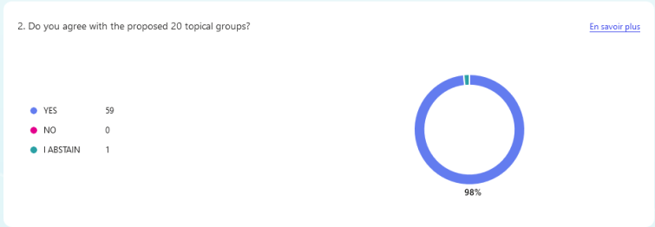
Figure 1. Results of the topical group selection vote

The 20 selected topical groups (KPI n°7) are the following:
- ALLIES (Alliances for Lifelong Learning, Improvement, Empowerment and Skills)
- Communication & Dissemination
- Community Engagement
- Cooperation with Ukraine
- Diversity & Inclusion
- European Degree & Joint Programmes
- European Universities Governance and Legal Frameworks
- Impact
- Innovation in Learning and Teaching
- Internationalisation and Global Outreach
- IT & Digitalization
- Library and Open Science
- Mobility
- Multilingualism and Multiculturalism
- Project Management
- Quality Assurance
- R&I
- Regional Innovation Ecosystems
- STEAM
- Student-led Community of Sustainable and Democratic Student Participation

The selected topical groups were announced on Wednesday 2nd April via an email to the General Forum and on the FOREU4ALL LinkedIn page (figure 2).

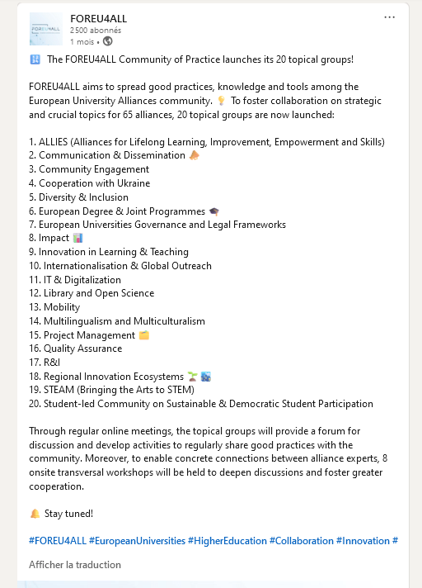
Figure 2. FOREU4ALL LinkedIn Post announcing the selection of topical groups

Once the 20 topical groups were selected, alliance coordinators were invited to appoint representatives to participate in the groups. This process ran through the month of April and led to the creation of the mailing lists as well as inclusion of participants in the FOREU4ALL Teams workspace (Milestone 4).

The WP2 Project Officer planned bilateral meetings with all selected topical group proposers to prepare the organisation of the first meetings as well as the management and monitoring processes. The first topical group meetings were organised in May 2025 and included the election of each group’s inaugural Group Chairing Team (GCT).

MANAGEMENT, MONITORING AND EVALUATION PROCESSES

Topical group membership
Topical group members can only be representatives of European Universities alliances (EUAs) or Seal of Excellence consortia. They should be experts in the topical group related field(s) as defined in each of the Terms of Reference.

External stakeholders (such as associations or other HEI actors) can be invited to participate in the meetings or activities of topical groups when deemed appropriate by its members. However, they cannot be full and regular topical group members as the main objective of those groups is to share best practices and experiences among EUAs.

Topical group management

At the topical group level
Each topical group elects their group Chair and Vice-Chair(s), forming a Group Chairing Team (GCT). The GCT takes care of organising regular online meetings and topical group activities. The GCT mandate duration is two years, renewable (unless stated otherwise in the group’s Terms of Reference).

The topical groups can be chaired by any of the 65 alliances.

GCTs thereby accept that their role entails that their contact information is shared internally across the FOREU4ALL Governance to the Project Management Team, General Forum and Advisory Board.

At the CoP level
The WP2 Project Officer manages the mailing lists and online environment of the topical groups, with the support from the WP1 Project Officer and WP4 Communication Officer.

The WP2 Project Officer provides templates for the agendas and meeting minutes (see section VI.).

The WP2 Project Officer oversees the overall management of the topical groups and supports GCTs in the management of their group.

Topical group monitoring
GCTs report to the WP2 Project Officer and Board so that topical group outputs can be fed into the activities of other Work Packages (WP3 for Policy Learning Labs and WP4 for dissemination of results and best practices).

The WP2 Project Officer and Board will organise monitoring meetings will all GCTs between 2 and 3 times a year. Those meetings are the opportunity for GCTs to identify synergies with other topical groups on similar/complementary topics. They will also be the place to discuss CoP workshops, report on activities and outputs to disseminate to the wider community.

The first meeting between the WP2 Board and GCTs was organised on Thursday 3rd June 2025 to discuss the management, monitoring and evaluation processes of the topical groups as well as the first call for workshops.

In turn, the elected GCTs are expected to:
- Organise regular online meetings with their group (by using the mailing list to share the information and by adding meeting dates to the shared calendar on Teams);
- Provide the agendas and minutes both to their groups and WP2 Project Officer for monitoring purposes (by storing the agendas and minutes in the shared folder on Teams);
- Provide (and update if necessary) their topical group Terms of Reference;
- Provide regular reports on activities and, at least, one written report per year to the WP2 Board to ensure that topical group activities can inform/feed the activities of the FOREU4ALL Governing bodies, WP3 Policy Dialogue and WP4 Communication and Dissemination;
- Be the contact points for consultations from external stakeholders;
- Remain informed of what the activities of other topical groups are to foster cross-group collaborations (notably for the on-site CoP workshops);
- Implement concrete productions with their group, to be included in the WP2 deliverables (D2.2 topical groups report #1 and D2.03 topical groups report #2) and to be published as best practices on the FOREU4ALL website.

These modalities are defined to ensure that topical groups are properly running. The regular contact between GCTs and WP2 Project Officer will ensure that potential issues are avoided or rapidly solved.

Evaluation of topical groups
Topical groups are expected to produce concrete results, such as reflection papers as well as collections of good practices and expertise on these different topics.

The groups shall run their activities until the end of the FOREU4ALL project unless the topic is not of priority strategic interest for alliances anymore.

Hence, the activities and relevance of the groups will be evaluated yearly based on the regular reports and concrete productions provided by the GCTs to the WP2 Board. A template for the yearly written report will be provided by the WP2 Project Officer in Autumn 2025 and the first yearly evaluation will take place in June 2026, approximately a year after the launch of the topical groups. There will then be a yearly report to be submitted in June 2027 and June 2028 (last year of the project).

Additionally, if the WP2 Board does not receive those regular reports and if the groups do not implement concrete productions, they may be reviewed (either at the level of the WP2 Board, Project Management Team or General Forum depending on the case) and terminated if deemed necessary.

In case of disagreement or issues within a topical group, the GCT can consult the WP2 Board in order to identify solutions and a way forward.

TOPICAL GROUPS COMMUNICATION STRATEGY
The launch of the topical groups is a crucial milestone in the life of the FOREU4ALL project. A key element for the launch was therefore the internal and external communication and dissemination strategy. The communication surrounding the launch was thus in line with the overall Communication and Dissemination strategy outlined by WP4.

1. Internal strategy
The main initial target group for the launch of the topical group is the FOREU4ALL Governance, as widespread knowledge across the 65 alliances is essential so that all alliances participate in the topical groups.

The General Forum was thus involved from the start as they have voted to select topical groups.

Following the results of the vote, the General Forum was immediately contacted and the 65 alliances composing the General Forum were invited to appoint representatives to participate in the topical group activities.

As of July 2025, 62 out of 65 alliances are now involved in at least 2 topical groups: the table below details the number of alliances participating in each topical group. There are between 49 and 132 alliance representatives per group.

Topical group | Number of alliances involved in the topical group (with at least one representative)
ALLIES | 50
Communication & Dissemination | 61
Community Engagement | 56
Cooperation with Ukraine | 49
Diversity and Inclusion | 52
European Degree and Joint Programmes | 59
European Universities Governance and Legal Frameworks | 62
Impact | 58
Internationalisation and Global Outreach | 58
UIIE | 60
IT & Digitalisation | 60
Library and Open Science | 53
Mobility | 62
Multilingualism and Multiculturalism | 50
Project Management | 62
Quality Assurance | 59
R&I | 57
Regional Innovation Ecosystems | 53
STEAM | 37
Student-led Community | 49
Table 1. Alliance participation in topical groups

95,4% of alliances are therefore participating in at least two topical groups 3 months after their launch (KPI n°8). In total, there are 2042 members (KPI n°9) in the 20 topical groups.

This high participation rate confirms the success of the internal communication strategy within the FOREU4ALL main governing body. Regular updates will be provided to the General Forum on the activities of the groups. Moreover, alliances can appoint representatives to participate in the groups at any time throughout the project by contacting the WP2 Project Officer.

The External Advisory Board has also been a key target, as there are a shared interests from alliances and sector representatives to collaborate on various topics. The topical groups were presented to the External Advisory Board on Tuesday 29 April 2025. The contact details of the GCTs were shared with the External Advisory Board to foster collaborations with the topical groups.

Overall, the WP2 Board and Project Officer have ensured that the FOREU4ALL Governance was informed of the launch of the topical groups and the start of their activities.

External strategy
In collaboration with WP4, the launch of the topical groups was also communicated through public FOREU4ALL channels.

As explained in section II. Selection Process, the selected topical groups were immediately advertised on the FOREU4ALL LinkedIn page.

In addition, the list of topical groups, including their description, objectives and GCT composition was added on the FOREU4ALL website (Figure 3). As the topical groups develop their activities, the webpage will be updated with more information.

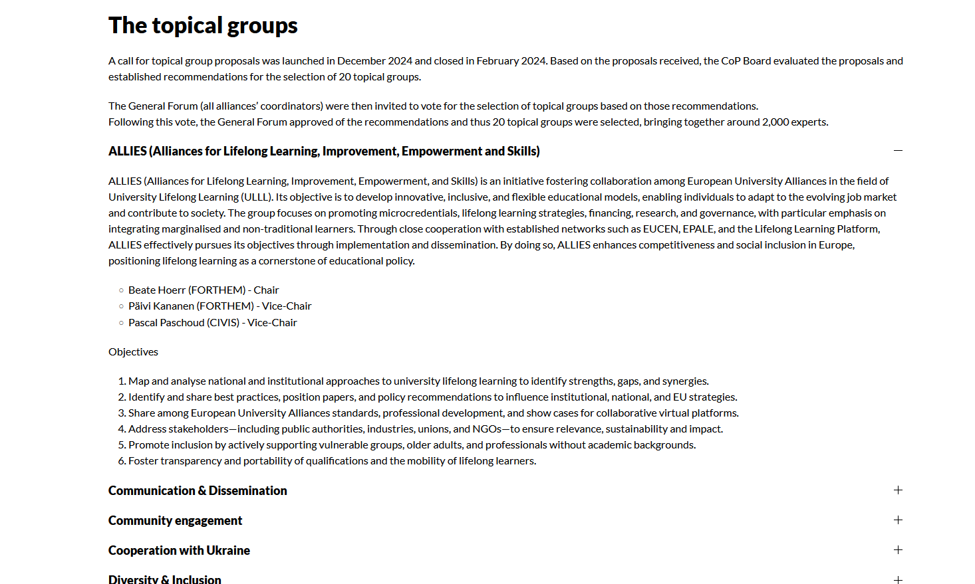
Figure 3. Example of a topical group description on the FOREU74ALL website.

The topical groups were also already (re)presented in a series of external events following their launch, as detailed in the table below.

Organiser | Type of event | Place | Date | Title/Short Description
FOREU4ALL Central Office | Meeting | ECIU Office, Brussels (BE) | 29/04/25 | Meeting with university sector representatives
CRASP, France Universités, CDEFI and EUA | Seminar | Maison Irène & Frédéric Joliot-Curie, Brussels (BE) | 13/05/25 | Implementation of the European degree label and next steps towards a joint European Degree
Campus France | Meeting | Campus France office, Paris (FR) | 16/05/25 | Future4Alliances kick-off meeting
Neth-ER | Meeting | Neth-ER office (Brussels) | 23/05/25 | Discussing the future of the EUI in the context of the Dutch knowledge field.
EURASHE | Meeting | Online | 02/06/25 | Sounding Board
France & Germany alliances event | Conference | In-person | 16-17/06/25 | Key event fostering dialogue and collaboration between institutions from both countries
IUEBO (Italian Universities Brussels/European Offices | Seminar | In-person | 16/06/25 | Presentation of FOREU4ALL followed by Q&A session
Romanian HEIs | Seminar | online | 18/06/25 | Spill-over effects to HEIs that are not part of EUAs, relevance of national networks
DAAD | Meeting | Online | 22/06/25 | Presentation of EUI-related support projects (FOREU4ALL, CMEPIUS/ACA TCA study on needs of HEIs from NAs and Future4Alliances
French Erasmus+ Agency | Seminar | In-person, Bordeaux (FR) | 1-2/07/2025 | Higher Education Erasmus+ Days

Table 2. List of events where topical groups were (re)presented.

These events provided a first stage in which topical groups were introduced to the wider HE community and policy makers or involved directly in the event programme (Seminar on European Degree with the presence of the European Degree and Joint Programmes topical group representatives).

Now that they have been launched, topical groups will be able to contribute more widely to the activities of the sector via dedicated workshops and regular updates on the FOREU4ALL website and LinkedIn page.

TEMPLATES
The agenda and templates used for topical groups were provided by WP4 Communication and Dissemination. They are available to all members on Teams.

1. Agenda template
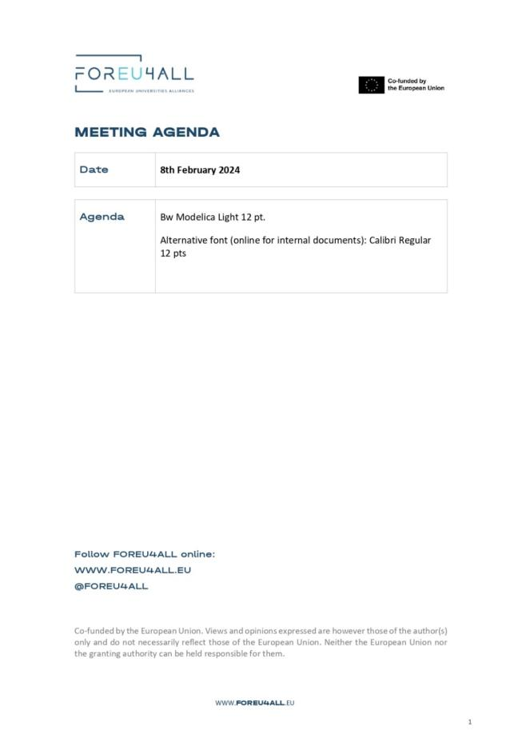

Minutes template
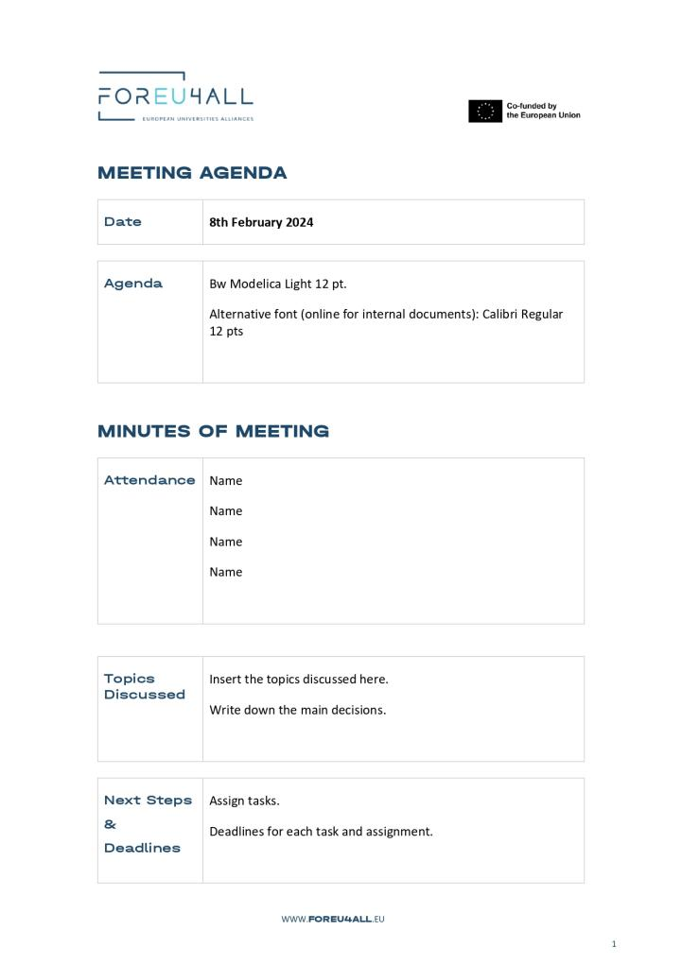

CONCLUSION
The CoP topical groups were successfully launched and established in the period April-June 2025. This launch has followed a structured selection process, and the setup of clear management, monitoring and evaluation processes.

The 20 selected topical groups have successfully organised their first meeting in May 2025, elected their GCT and defined their Terms of Reference, based on the template provided by WP2. They have started the rollout of their activities and will regularly share their outputs with WP2, so that they can be disseminated by WP4 through the different FOREU4ALL public channels.

A clear strategy was defined to promote this launch internally to alliances and maximise their participation in the topical groups. They were also advertised to external stakeholders, including university sector representatives and policy-makers.

Consequently, more than 2000 participants are active members of the topical groups, far beyond the initial target of 300 representatives. Experts from all across Europe are now brought together and already have a concrete impact and spill-over effects beyond alliances for the wider sector. Notably, the European Degree and Joint Programmes topical group has been invited to take part in the ‘sounding board’ for the European Degree policy learning labs. The IT & Digitalization topical group is also advising on the new interoperability framework.

This overall strategy will continue to develop to ensure that topical groups are both relevant to the needs of alliances and foster collaborations with the wider sector. This will include ensuring that the 3 alliances not yet participating in the topical groups can get involved but also integrating the Seal of Excellence consortia starting in September 2025.

The launch of the topical groups is only the starting point of their activities, which will feed WP3 activities on policy dialogue and promoted via WP4 communication channels. The next steps will be the organisation of the first two onsite CoP workshops, for which topical groups will be invited to propose topics.

Follow FOREU4ALL online:
WWW.FOREU4ALL.EU
@FOREU4ALL

Co-funded by the European Union. Views and opinions expressed are however those of the author(s) only and do not necessarily reflect those of the European Union. Neither the European Union nor the granting authority can be held responsible for them.

After the first meeting of the group in May 2025, members have voted to rename the group “UIIE (Upscaling Internationalization and Innovation in Education)”.
This is the total number of participants. The number for each alliance representative would be slightly lower as some representatives are involved in several topical groups.

